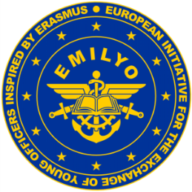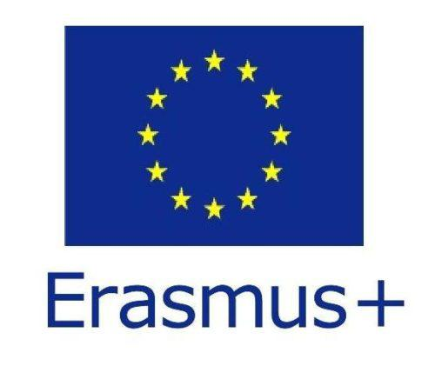



**Theresan**

**Military Academy**

**Certificate**



This is to certify that

**OCdt Abef GIHOPUJ**

passed the

Common Module

Basics of Crisis Management Operations

(Common Module PSO A)

**valid for 2 ECTS**

Wiener Neustadt, the 15th of November, 2019

|  |  |
| --- | --- |
| The Course Director: | The Head of International Office &  Chairman of the Military Erasmus (EMILYO) Implementation Group: |
|  |  |
| (Maj Mag. [FH] Alexander SPANNBAUER) | (Col Assoc. Prof. Harald GELL, PhD) |